FOR RELEASE AT 10:00 AM EST, TUESDAY, NOVEMBER 15, 2016
MANUFACTURING AND TRADE INVENTORIES AND SALES, SEPTEMBER 2016
Release Number: CB16-186

November 15, 2016 — The U.S. Census Bureau announced the following new manufacturing and trade statistics for September 2016:

BUSINESS INVENTORIES
SEPTEMBER 2016 | $1,818.7 billion | +0.1%*
AUGUST 2016  (revised) | $1,816.9 billion | +0.2%
Next release: December 14, 2016

Data adjusted for seasonality but not for price changes.
* The 90 percent confidence interval includes zero. In such cases, there is insufficient statistical evidence to conclude that the actual change is different from zero.
Source: U.S. Census Bureau, Manufacturing and Trade Inventories and Sales, November 15, 2016.
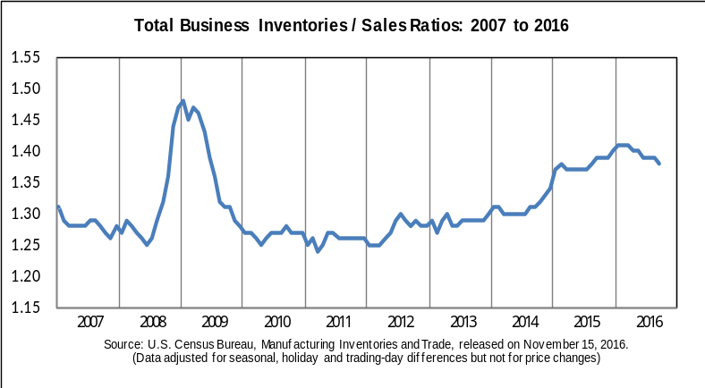

Sales
The combined value of distributive trade sales and manufacturers’ shipments for September, adjusted for seasonal and trading-day differences but not for price changes, was estimated at $1,314.6 billion, up 0.7 percent (±0.2 percent) from August 2016 and was up 0.8 percent (±0.4 percent) from September 2015.
Inventories
Manufacturers’ and trade inventories, adjusted for seasonal variations but not for price changes, were estimated at an end-of-month level of $1,818.7 billion, up 0.1 percent (±0.1 percent)* from August 2016 and were up 0.6 percent (±0.6 percent)* from September 2015.
Inventories/Sales Ratio
The total business inventories/sales ratio based on seasonally adjusted data at the end of September was 1.38. The September 2015 ratio was 1.39.
General Information
With the release of the November 2016 Manufacturing and Trade Inventories and Sales Report on January 13, 2017, the presentation of the release will change. We are removing the text portion of the release from Excel. The redesigned text will be available as a Word document. The layout and format of the tables are not currently changing, though some explanatory notes may move to the text portion of the document. The full text and tables will still be available as a PDF. For more information and a preview of the new format, visit <www.census.gov/mtis/> .
The October 2016 Manufacturing and Trade Inventories and Sales Report is scheduled for release on December 14, 2016. View the full schedule in the Economic Briefing Room: <www.census.gov/economic-indicators/>.
EXPLANATORY NOTES
Reliability of Estimates
The sampling variability for retailers and merchant wholesalers can be used to construct a 90 percent confidence interval for the estimates. Over all possible samples, 90 percent of such intervals will cover the true estimate. These intervals are given in parentheses for the estimates on the front page. If, for example, the estimate is up 0.8 percent and the margin of sampling error is ±1.2 percent, the 90 percent confidence interval is -0.4 percent to +2.0 percent. If the range contains 0, it is uncertain whether there was an increase or decrease. Measures of reliability for Retail and Wholesale sales and inventory levels and changes are included in the detailed monthly press releases for those Industries. Manufacturers do not contribute to estimates of sampling variability because the manufacturer’s mail panel is not a probability sample from a known frame and standard errors of the industry estimates cannot be calculated. Estimates from all three surveys are also subject to nonsampling errors, which can arise in any stage of the survey. Such errors include coverage error (failure to accurately represent all population units in the sample) response errors, coding errors, and nonresponse. Although no direct measurement of these errors has been obtained, precautionary steps were taken in all phases of the collection, processing, and tabulation of the data to minimize their influence.
Description of the Survey
The Manufacturing and Trade Inventories and Sales estimates are based on data from three surveys: the Monthly Retail Trade Survey, the Monthly Wholesale Trade Survey, and the Manufacturers’ Shipments, Inventories, and Orders Survey. Data for the wholesale and manufacturing sectors are unrevised from the most recent Monthly Wholesale Trade Report and the Full Report on Manufacturers’ Shipments, Inventories and orders. Data from the Retail sector is revised and presented in more detail from the most recent Advance Economic Indicators Report. For more information on these surveys see the links below: <www.census.gov/retail/>, <www.census.gov/wholesale/>, and <www.census.gov/manufacturing/m3/>.
America’s Economy Mobile App
The America’s Economy app provides real-time updates for 19 key economic indicators released from the Census Bureau, Bureau of Labor Statistics, and Bureau of Economic Analysis.
<www.census.gov/mobile/economy/>
API
The Census Bureau’s application programming interface lets developers create custom apps to reach new users and makes key demographic, socio-economic and housing statistics more accessible than ever before.
<www.census.gov/developers/>
-X-
* The 90 percent confidence interval includes zero. In such cases, there is insufficient statistical evidence to conclude that the actual change is different from zero.

