FOR RELEASE AT 10:00 AM EST, WEDNESDAY, NOVEMBER 9, 2016
MONTHLY WHOLESALE TRADE: SALES AND INVENTORIES, SEPTEMBER 2016
Release Number: CB16-184

November 9, 2016 — The U.S. Census Bureau announced the following new wholesale trade statistics for September 2016:
 | MONTHLY WHOLESALE INVENTORIES
SEPTEMBER 2016 |  | $590.2 billion | +0.1%*
AUGUST 2016 (revised) |  | $589.4 billion | -0.1%*
Next release: December 9, 2016

Data adjusted for seasonality but not for price changes.
* The 90 percent confidence interval includes zero. In such cases, there is insufficient statistical evidence to conclude that the actual change is different from zero.
Source: U.S. Census Bureau, Monthly Wholesale Trade, November 9, 2016.
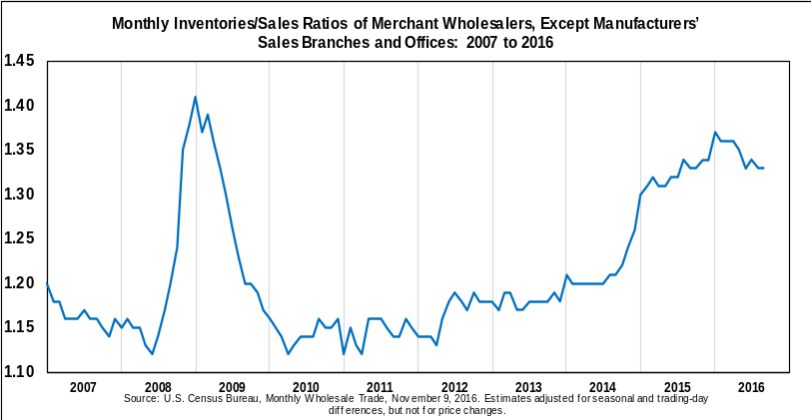

Sales
September 2016 sales of merchant wholesalers, except manufacturers’ sales branches and offices, after adjustment for seasonal variations and trading-day differences but not for price changes, were $444.9 billion, up 0.2 percent (±0.4 percent)* from the revised August level and were up 0.4 percent (±1.1 percent)* from the September 2015 level. The July 2016 to August 2016 percent change was unrevised from the preliminary estimate of up 0.7 percent (±0.5 percent).
Inventories
Total inventories of merchant wholesalers, except manufacturers’ sales branches and offices, after adjustment for seasonal variations but not for price changes, were $590.2 billion at the end of September, up 0.1 percent (±0.2 percent)* from the revised August level. Total inventories are down 0.1 percent (±1.9 percent)* from the revised September 2015 level. The August 2016 to September 2016 percent change was revised from the advance estimate of up 0.2 percent (± 0.4 percent)* to up 0.1 percent (±0.2 percent)*.
Inventories/Sales Ratio
The September inventories/sales ratio for merchant wholesalers, except manufacturers’ sales branches and offices, based on seasonally adjusted data, was 1.33. The September 2015 ratio was 1.33.
General Information
With the release of the November 2016 Monthly Wholesale Trade Report on January 10, 2017, the presentation of the release will change. We are removing the text portion of the release from Excel. The redesigned text will be available as a Word document. The layout and format of the tables are not currently changing, though some explanatory notes may move to the text portion of the document. The full text and tables will still be available as a PDF. For more information and a preview of the new format, visit <www.census.gov/wholesale/>.
The October 2016 Monthly Wholesale Trade Report is scheduled for release on December 9, 2016. View the full schedule in the Economic Briefing Room: <www.census.gov/economic-indicators/>.
For additional survey information, including customizable time series estimates by industry, visit <www.census.gov/wholesale/>.
EXPLANATORY NOTES
Reliability of the Estimates
Because the estimates presented in this report are based on a sample survey, they contain sampling error and nonsampling error.
Sampling error is the difference between the estimate and the result that would be obtained from a complete enumeration of the sampling frame conducted under the same survey conditions. This error occurs because only a subset of the entire sampling frame is measured in a sample survey. Standard errors and coefficients of variation, as given in Table 2 of this report, are estimated measures of sampling variation.
The margin of sampling error , as used on page 1, gives a range about the estimate, which can be used to construct a 90-percent confidence interval. If, for example, the percent change estimate is +1.2 percent and its estimated standard error is 0.8 percent, then the margin of sampling error is ±1.753 x 0.8 percent or ±1.4 percent, and the 90 percent confidence interval is 1.2 +/-1.4 or -0.2 percent to 2.6 percent. If the interval contains 0, then one does not have sufficient statistical evidence to conclude at the 90 percent confidence level that the actual change is different from zero. Estimated changes shown in the text are statistically significant unless otherwise noted. For a monthly total, the estimated coefficient of variation is given. The resulting confidence interval is the estimated monthly total ± 1.753 × CV × (the estimated monthly total). The Census Bureau recommends that individuals using estimates in this report incorporate this information into their analyses, as sampling error could affect the conclusions drawn from the estimates.
Nonsampling error encompasses all other factors that contribute to the total error of a sample survey estimate. This type of error can occur because of nonresponse, insufficient coverage of the universe of wholesale businesses, mistakes in the recording and coding of data, model error, and other errors of collection, response, coverage, or processing. Although nonsampling error is not measured directly, the Census Bureau employs quality control procedures throughout the process to minimize this type of error.
Description of the Survey
The Census Bureau conducts the Monthly Wholesale Trade Survey to provide national estimates of monthly sales, end-of-month inventories, and inventories-to-sales ratios by kind of business for wholesale firms located in the United States. Specifically, the MWTS covers wholesale merchants who sell goods on their own account and include such businesses as wholesale merchants or jobbers, industrial distributors, exporters, and importers. Sales offices and branches maintained by manufacturing, refining, or mining firms for the purpose of marketing their products are not covered in this report. Also excluded is NAICS Industry Group 4251: Wholesale Electronic Markets and Agents and Brokers.
The MWTS sample was selected using a stratified, one-stage design with strata defined by kind of business (e.g., Automotive, Furniture, Lumber, etc.) and annual sales size. The sample includes firms of all sizes and is updated on a quarterly basis to account for new wholesale firms, deaths, and other changes to the wholesale universe. Each month, questionnaires are mailed to employer firms selected in a probability sample of approximately 4,200. For surveyed companies, approximately 65.4 percent provided data for this reporting period, resulting in a total quantity response rate of 65.1 percent for sales and 65.3 percent for inventories.
Monthly sales and inventories estimates are obtained by summing weighted data (either reported or imputed). The monthly estimates are benchmarked to annual survey estimates and are adjusted for seasonal variation and trading-day differences. Individuals who use estimates in this report to create new estimates should cite the Census Bureau as the source of only the original estimates. Additional information on the MWTS can be found on the Census Bureau website at: <www.census.gov/wholesale/>.
America’s Economy Mobile App
The America’s Economy app provides real-time updates for 19 key economic indicators released from the U.S. Census Bureau, Bureau of Labor Statistics, and Bureau of Economic Analysis.
<www.census.gov/mobile/economy/>
API
The Census Bureau’s application programming interface lets developers create custom apps to reach new users and makes key demographic, socio-economic and housing statistics more accessible than ever before.
<www.census.gov/developers/>
-X-
* The 90 percent confidence interval includes zero. In such cases, there is insufficient statistical evidence to conclude that the actual change is different from zero.

